NGSS Performance Expectation
HS-PS1-4. Develop a model to illustrate that the release or absorption of energy from a chemical reaction system depends upon the changes in the total bond energy.

Name_________________________ Period______

Lesson: Thermochemistry Grades 9-11

# | Success Criteria
1 | I can identify that breaking bonds require energy and making bonds release energy.
2 | I can use evidence to develop a model for identifying system, surroundings and transfer of energy between them in an exo- and endothermic reaction.
3 | I can use mathematical computations using bond energy to predict exo- and endothermic reactions.
4 | Using particulate level models, I can explain energy transfer in terms of bonds broken and formed in exo- and endothermic reactions.
5 | I can construct an explanation from temperature data to explain why exothermic reactions feel warm and endothermic reactions feel cold to touch.
6 | I can track the energy flow in and out of the system in an exo- and endothermic reaction using energy diagrams.
Lesson 1 Day 1:
- Prior Knowledge
Discuss the following questions in your group and be ready to report out to the class after your discussion. Have you or anyone you know ever used an ice pack or a hot pack and what are they used for? How are these packs used?
Write a summary of the class discussion answering the above two questions.
II. Energy Changes and Bonding: Recall the relationship between energy changes and bond formations using the following pHET interactive.
Go to https://phet.colorado.edu/sims/html/atomic-interactions/latest/atomic-interactions_en.html
Notice the energy changes as you bring two Argon atoms closer or pull them apart. Repeat the same with two Oxygen atoms. Now, watch the following video and summarize your learning from the interactive and the video. https://www.youtube.com/watch?v=dvJaBUxaYuk
Bond breaking _____________(requires/releases) energy and bond making_______________(requires/releases) energy.
Explain the above statement using the following words: energy, attractive forces, absorbs energy, releases energy, attraction)
III. Performance Task: Understand the correlation between temperature change and energy transfer Wear goggles and apron before conducting the following performance task.
- As a group, add 50 mL of water to the beaker. Measure the temperature of solution using thermometer. Add one spoonful of solid Sodium Acetate in 50 mL of water. Dissolve it and measure the temperature again. Record temperatures. Now, repeat this procedure with a spoonful of Ammonium Nitrate in a separate beaker and record the temperatures.

Observations

- Using the picture of solid NaCl dissolving in water below as a model, draw the Macro and Particulate level drawings of Sodium Acetate and Ammonium Nitrate dissolving in the table given below.

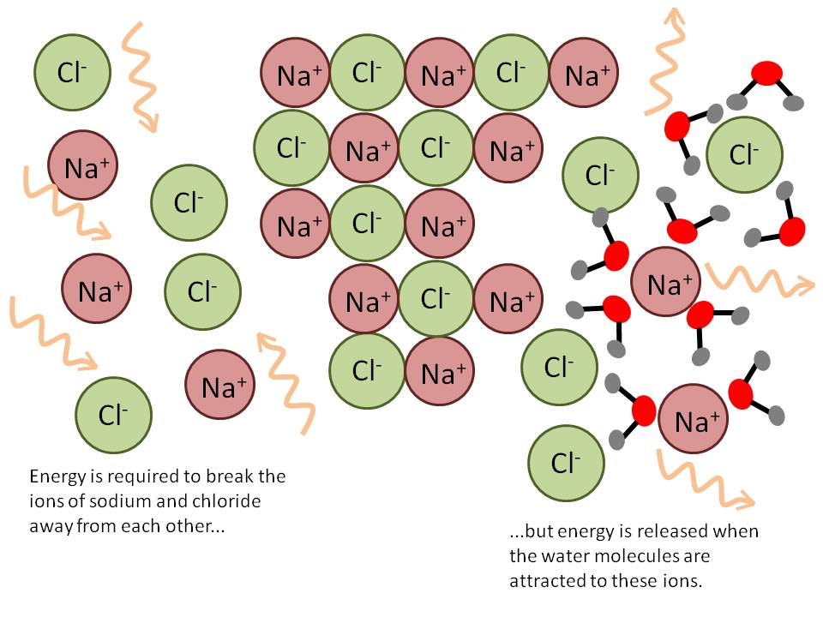
https://www.discoveryexpresskids.com/blog/exothermic-vs-endothermic-chemistrys-give-and-take

 | Sodium Acetate (solid) | Water |  | Sodium Acetate (aqueous)
Chemical Formula

Macro Drawing (as you see with your eyes)

Particulate Level Drawings

Bonds Broken |  |  |  | X
Bonds Formed | X | X

 | Ammonium Nitrate (solid) | Water |  | Ammonium Nitrate (aqueous)
Chemical Formula

Macro Drawing (as you see with your eyes)

Particulate Level Drawings

Bonds Broken |  |  |  | X
Bonds Formed | X | X

Exit Slip: Fill in the blanks
- When the amount of energy required to break the bonds is less than the energy released during the bond formation, the reaction will _______________________ (release/absorb) energy.

- When the amount of energy required to break the bonds is more than the energy released during the bond formation, the reaction will _______________________ (release/absorb) energy.

Lesson 2 Day 2

- System and Surroundings
Now, let us understand two terms, system and surrounds. System is that part of the universe that you are focusing your attention on and surrounding is everything around it.
- Identify system and surroundings in each of the beakers in your performance task.

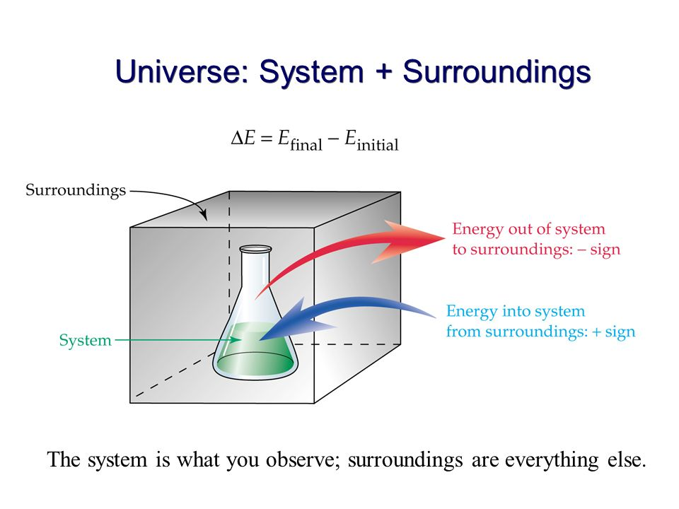 | Label system and surrounding in the following pictures.  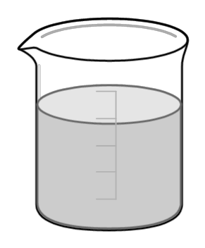  Aq. Sodium Acetate Aq. Ammonium Nitrate

- Exothermic and Endothermic Reactions
- When the energy needed to break bonds is lesser than energy released by bond formation, the net energy change is ______________(positive/negative). This means that system will ____________(lose/gain) energy and surrounding will ________________ (lose/gain) heat. This type of reaction is called as exothermic reactions.

- When the energy needed to break bonds is greater than energy released by bond formation, the net energy change is ______________(positive/negative). This means that system will ____________(lose/gain) energy and surrounding will ________________ (lose/gain) heat. This type of reaction is called as endothermic reactions.

- Label system, surroundings and the direction of heat transfer for exo- and endothermic reactions.
Exothermic Reaction | Endothermic Reaction

VI. Understanding Exo- and Endothermic reactions through Mathematical Computations

Given the following bond energy data and fill in the following table:
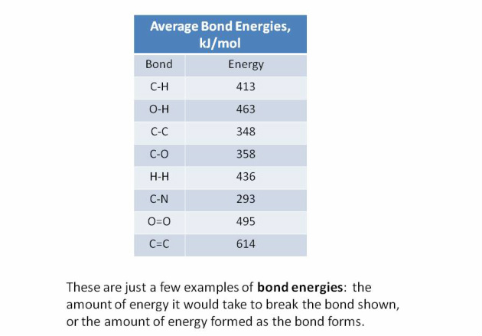

Complete the following table.
 | 2 H₂ | + | O₂ |  | 2H₂O
# and types of bonds broken or formed
Energy for each of these bonds
Total energy needed to break the reactant bonds |  |  |  |  | Total energy released in forming product bonds
Is the above reaction endo- or exothermic? How do you know?

VII. Energy Diagrams

Endo- and exothermic reactions can be represented by energy diagrams as given in the picture below. Watch this video for further clarification https://www.youtube.com/watch?v=5-TPVHIi39w
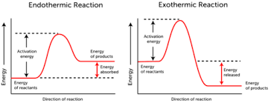

Which energy diagram, first or the second corresponds to the dissolution of Ammonium Nitrate? Explain.

Draw the energy diagram for the dissolution of Sodium Acetate.

VIII. Formative Assessment Day 3

- On a binder paper, draw particulate level diagram for dissolution of solid Ammonium Nitrate and solid Sodium Acetate before and after the salt was dissolved. For each of the diagrams, label system, surroundings, bonds broken, bonds formed and exo or endothermic and draw the energy diagram. Now, put these papers in the middle.
- Using the white board, answer the question again and learn from collective group understanding. Now, write one group report answering the same question.
- Staple each of the individual and the group report together and turn in to the teacher.

Formative Assessment- Individual Group Member Report

Complete the following table. Then put these papers in the middle.

Particulate Level Ammonium Nitrate Before Dissolution | Particulate Level Ammonium Nitrate After Dissolution, label system and surroundings
Name bonds broken=  Name bonds formed= | Draw Energy Diagram

Particulate Level Sodium Acetate Before Dissolution | Particulate Level Sodium Acetate After Dissolution, label system and surroundings
Name bonds broken=  Name bonds formed= | Draw Energy Diagram
Formative Assessment- Group Report (one per group of 4 students)

Complete the following table. Only one report required per group.

Particulate Level Ammonium Nitrate Before Dissolution | Particulate Level Ammonium Nitrate After Dissolution, label system and surroundings
Name bonds broken=  Name bonds formed= | Draw Energy Diagram

Particulate Level Sodium Acetate Before Dissolution | Particulate Level Sodium Acetate After Dissolution, label system and surroundings
Name bonds broken=  Name bonds formed= | Draw Energy Diagram
Grading Rubric
4 | 3 | 2 | 1
Provides evidence for understanding of ALL success criteria | Provides evidence of understanding of 2/3 of all criteria with at least one criteria in each | Provides evidence of understanding of ½ of all criteria in each dimension | Provides insufficient evidence of understanding in half of all criteria.

Name: Per:

Reflection Sheet for Formative Assessment on Thermochemistry

- What I already knew before group discussion?

- What I learned through the group discussion.

- How will I modify my response if I had to write it over again?

Lesson 3 Performance Task 2: Designing a Hand Warmer

Performance Expectation
HS-ETS1-3. Evaluate a solution to a complex real-world problem based on prioritized criteria and trade-offs that account for a range of constraints, including cost, safety, reliability and aesthetics as well as possible social, cultural and environmental impacts.

# | Success Criteria
1 | I can plan and conduct an experiment to identify the best chemical in terms of temperature change for the hand warmer.
2 | I take appropriate safety precautions in the lab including goggle use and disposal of chemicals.
3 | I can construct an explanation to identify the most environmentally friendly chemical based on my research.
4 | I can I can use mathematical computations to find the most economical chemical for the hand warmer based upon my research.
5 | I engage in argument from evidence in justifying for the best chemical for hand warmer based upon environmental friendliness, cost effectiveness and temperature change.
6 | I can modify my experimental design to get the appropriate data for the best hand warmer.
Now that you have the understanding of how bond breaking and forming can impact the energy transfer, you can use it to design a hand warmer. But before you can design a hand warmer, let us learn little more about the hand warmers.
Day 4

- What is a hand warmer? Watch the video https://www.youtube.com/watch?v=lrCzAGPwcIY
And identify the difference between a one-time use and a recyclable hand warmer.

- Criteria for A Good Hand Warmer
  - Volume and Temperature Increase: A good hand warmer should fit comfortably in the palm of your hand and has a volume of 50 mL. It should gently increase the temperature by around 20 degrees.

  - Environmental Friendliness: A good hand warmer should not contain harsh or environmentally unfriendly chemicals because most hand warmers are disposed off after one use. You can see the impact of different chemicals by reading the MSDS (Material Safety Data Sheet) of the chemical

  - Cost Effectiveness: Cost effectiveness definitively is one of the criteria for a good hand warmer. You can find the cost of different chemicals through Internet research.

- Designing your own hand warmer
  - You have three different chemicals, Ammonium Nitrate, Calcium Chloride and Sodium Acetate. Come up with an experimental design to gather data for gentle and desired temperature increase for the hand warmer. After getting consensus within your group about the experimental design, get approval from your teacher before proceeding on to do the experiment.

Experimental Design: Remember, a good hand warmer should fit comfortably in the palm of your hand and has a volume of 50 mL. It should gently increase the temperature by around 20 degrees.

Experimental Design Improvements after teacher feedback

- Conducting the Experiment and Data Collection

Research the MSDS of the three chemicals and for each of the chemicals identify the
toxicity to the environment.
Chemical 1:

Chemical 2:

Chemical 3:

Through internet research, find the cost of each of the three chemicals and then compute this cost for the amount that you will be using in the hand warmer. Show all work.

Class Data for Designing the Hand Warmer

 |  | Criteria #1 |  |  | Criteria #2 |  |  | Criteria #3
Salt | Temperature Change/g of salt (° C) | Avg. Temp Change/ g of salt (° C) | Time taken for temp. rise (° C) | Avg. Time taken for temp. rise (° C) | Cost of salt/g | Avg. Cost of Salt/g | Environ. Friendliness (high, medium or low) | Overall Environ. Friendliness
Ammonium Nitrate
Sodium Acetate
Calcium Chloride

- Draft 1: CER for hand warmer design lab. Share with a partner for peer review.

Claim: The best material for the hand warmer is ______________________.

Evidence:

Reasoning:

Draft 2: Edited CER after Peer Review

- Now self- assess your edited CER with the given rubric. Find any areas of growth and make edits.

Claim: The best material for the hand warmer is ______________________.

Evidence:

Reasoning:

Adapted from Cupertino High School, Cupertino, CA

Rubric for CER Paragraph
Criteria | 4 | 3 | 2 | 1
Claim  Evidence  Reasoning | Claim is correct, specific and answers the main question and attempts to generalize to a wider set of circumstances  Sufficient evidence is given for each of the three criteria  Sufficient reasoning is given for each of the three criteria connecting them to the claim | Claim is correct, specific and answers main question  Insufficient evidence is given for each of the three criteria  Insufficient reasoning is given for each of the three criteria connecting them to the claim | Claim answers the main question but can not be backed up by evidence from this activity  Sufficient evidence is given for two of the three criteria  Sufficient reasoning is given for two of the three criteria connecting them to the claim | Claim contradicts the evidence  Sufficient evidence is given for one of the three criteria  Sufficient reasoning is given for one of the three criteria connecting it to the claim

Draft 3: Draft 3 (Final Draft) of CER for the Performance Task

Claim: The best material for the hand warmer is ______________________.

Evidence:

Reasoning:

- Now, imagine that you are a manufacturer or consumer or environmentalist. Discuss the best material to use using different roles, consumer, manufacturer and environmentalist with your group.
Best Material from Consumer’s Point Summary:

Best Material from Manufacturer’s Point Summary:

Best Material from Environmentalist’s Point Summary:

Rubric for Debate for the best salt for hand warmer from the perspective of a manufacturer, a consumer and an environmentalist

Student’s argument for the desired salt align from the perspective of the role assigned (consumer or manufacturer or environmentalist) | Student considers the best salt from perspective of the role given. | Student demonstrates some understanding of the choice of the salt from the role’s perspective. | Student demonstrates minimal understanding of the choice of the salt based upon the role. | Student does not demonstrate understanding of the choice of the salt based upon the role.
Student is able to develop an argument for the best salt based upon the evidence | Student utilizes data to formulate a strong argument for the choice of the salt. | Student utilizes some data and creates a reasonable argument for the choice of the salt. | Student utilizes some data but creates a weak argument for the choice of the salt. | Student does not utilize data or does not have any evidence in support of the choice of the salt.

Designing the Hand Warmer: Watch the video https://www.nbcnews.com/video/cold-hands-warm-them-up-with-homemade-hand-warmers-1172589123616 and make your own hand warmer. Draw a picture of your hand warmer.

